# Project 1-1 Registration

## 1、Objective

Image registration is the process of transforming different sets of data into one coordinate system. Data may be multiple photographs, data from different sensors, times, depths, or viewpoints. It is used in computer vision, medical imaging and so on. Registration is necessary in order to be able to compare or integrate the data obtained from these different measurements. Because the registered image will show more details than a single image. In this project, we will register CT and ultrasound image named US to a whole image.

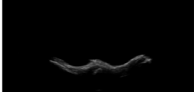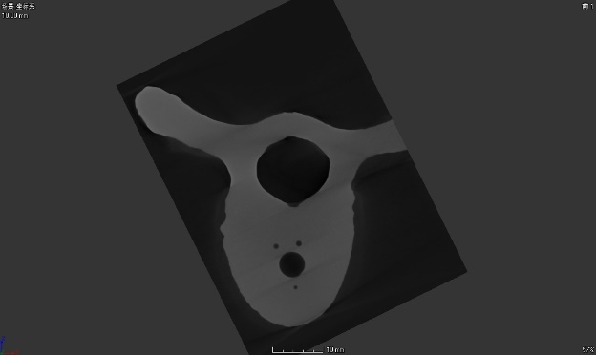

Picture1 CT image Picture2 US image

Picture 2 shows some details of the upper part of picture 1. So we need to do some operations to fuse them.

## 2、Method

When we prepare to fuse two different images, first thing we should do is searching a way to make the points from one image to another image, and make sure the points on where they should be. In Mathematics, searching a way can be easy to describe as finding a matrix to do transformation. For the same points in two different images, we can searching a matrix do this transformation. In this project, we fuse two 2D images. So we can describe matrix transformation like this.

X=t1*V+t2*W+t3*V*W+t4

Y=t5*V+t6*W+t7*V*W+t8

(x, y) is a point and (v, m) is the same point in another image.

For eight unknown parameter, we should find four points to calculate. So we can do like this.

So we can get the transformation matrix by calculating. Then we can get all the coordinates of points through this transformation matrix.

## 3、Result

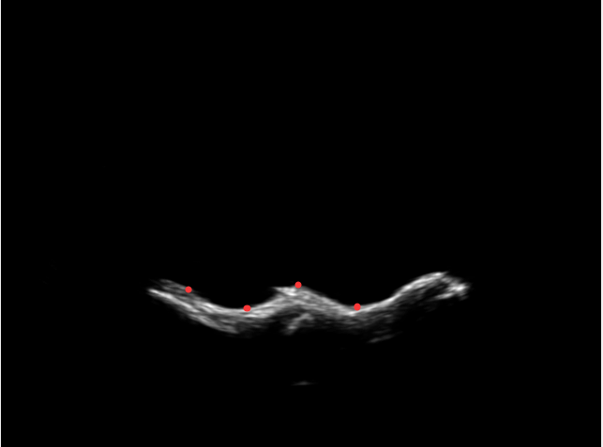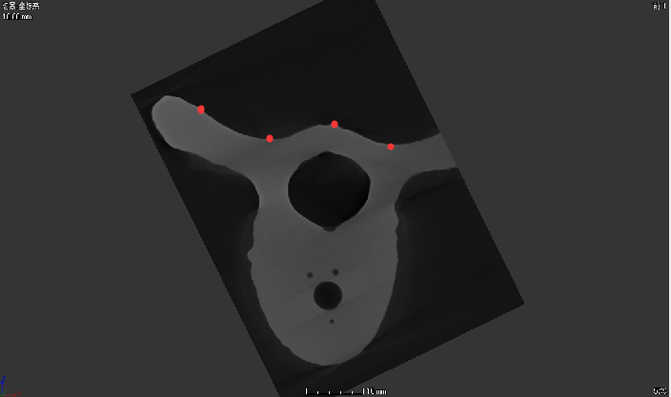

Picture 3 selected points of US Picture 4 selected points of CT

Picture 3 and 4 are selected points by hand. And we can get the fusion image like picture 5.

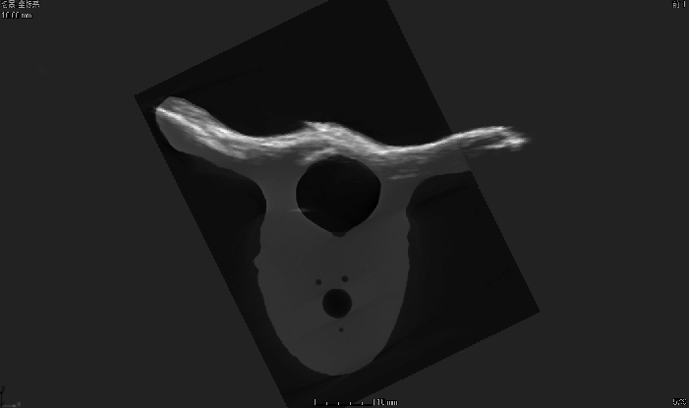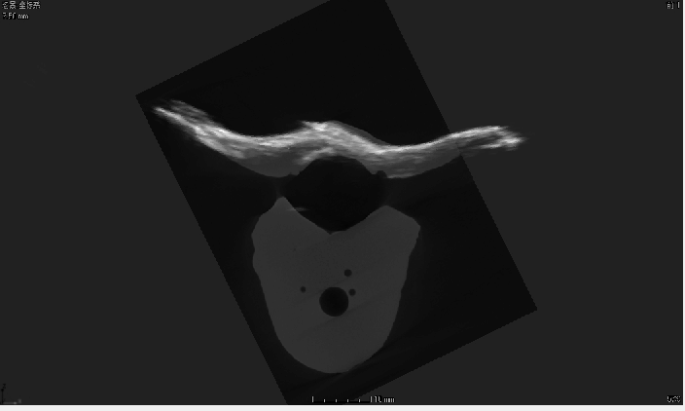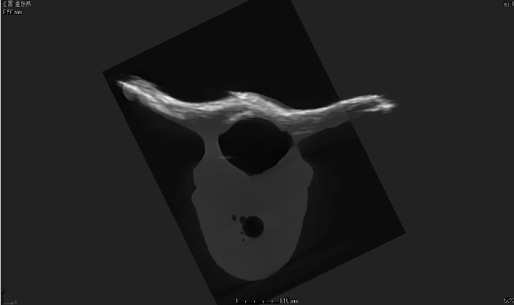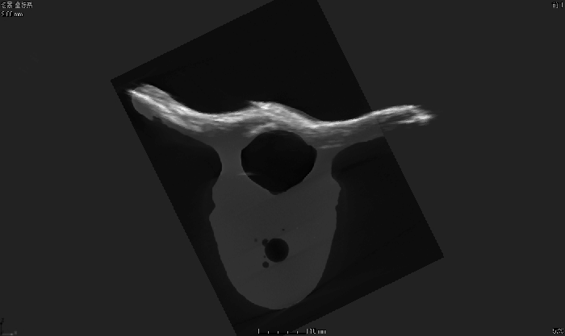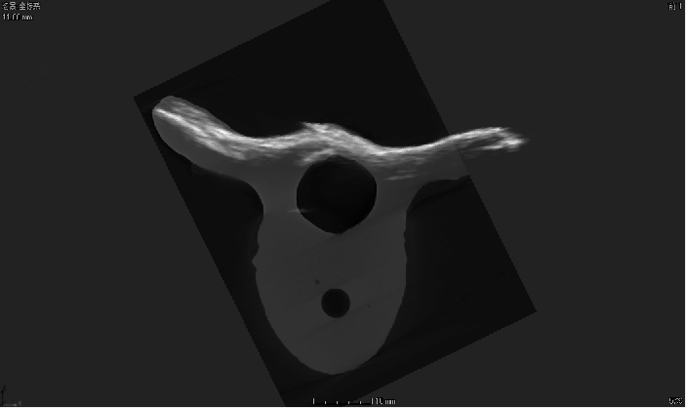

Picture 5 The fusion Images for different CT images

## 4、Discussion

For the criteria about selecting tie points. First, I search the local lowest points and the local highest points in the picture. Second, trying more times is best way to select tie points. Third, selecting tie points must be careful and focus on the screen. Some points may match some images well, but for another image, it could be bad.